4 - Test Techniques

## > Categories of Test Techniques

* Black-box Test Techniques
* White-box Test Techniques
* Experience-Based Test Techniques

## > Black-box Test Techniques

### Equivalence partitioning

Equivalence partitioning divides data into partitions in such a way that all the members of a given partition are expected to be processed in the same way

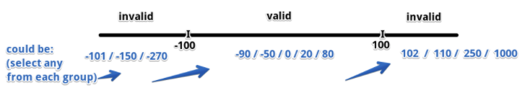

### Boundary value analysis

Is an extension of equivalence partitioning, but can only be used when the partition is ordered, consisting of numeric or sequential data. The minimum and maximum values of a partition are its boundary values

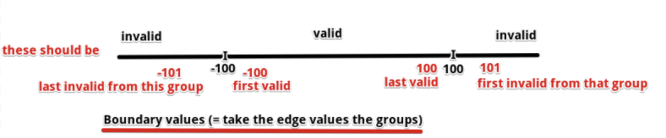

### Decision table testing

When creating decision tables, the tester identifies conditions and the resulting actions of the system.

Rows: conditions at the top and the actions at the bottom.

Column: represents decision rule.

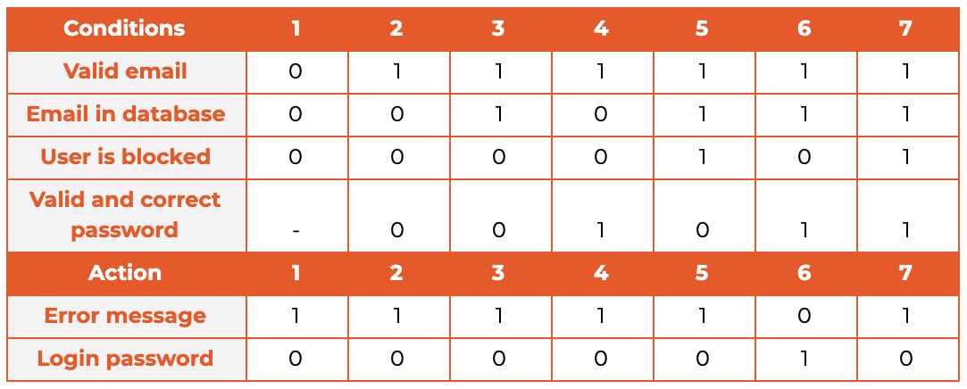

### State transition testing

A state transition diagram shows the possible software states, as well as how the software enters, exits, and transitions between states

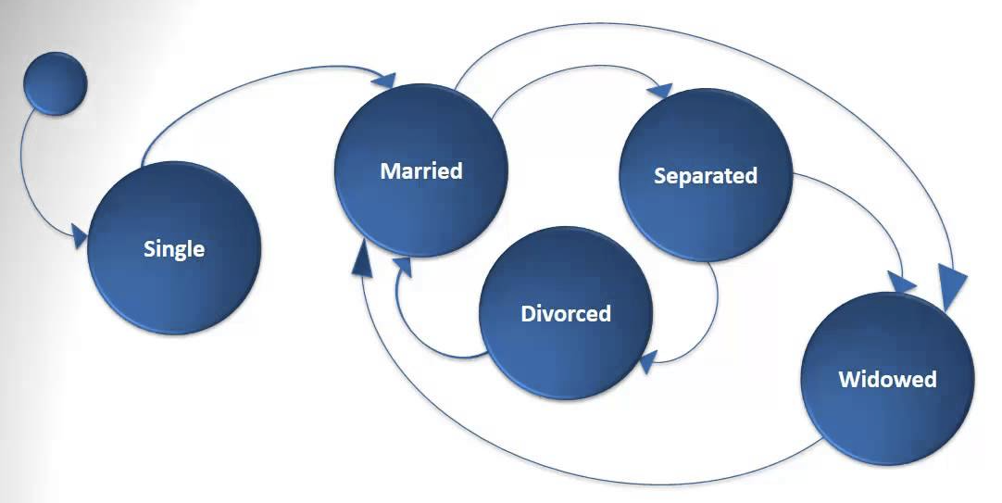

### Use case testing

Each use case specifies some behavior that a subject can perform in collaboration with one or more actors

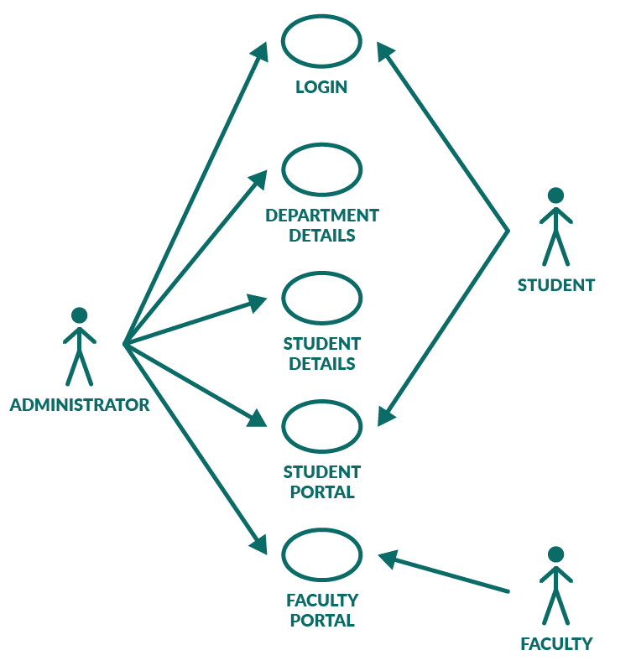

## > White-box Test Techniques

### Statement Testing and Coverage

Statement testing exercises the potential executable statements in the code.

Coverage = Number of statements executed / total number of executable statements

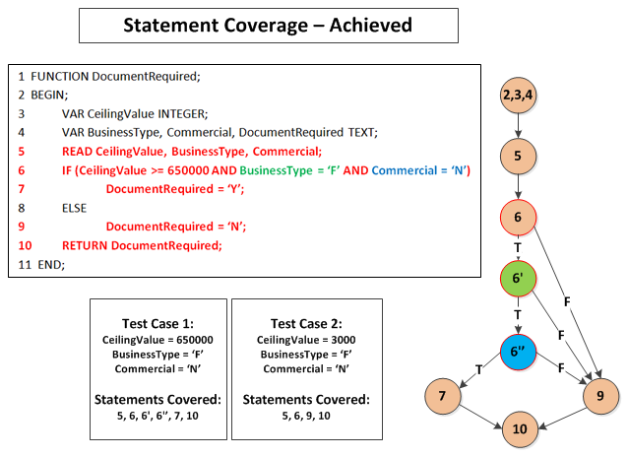

### Decision Testing and Coverage

Decision testing exercises the decisions in the code and tests the code that is executed based on the decision outcomes

Coverage = Number of decision outcomes executed / total number of decision outcomes

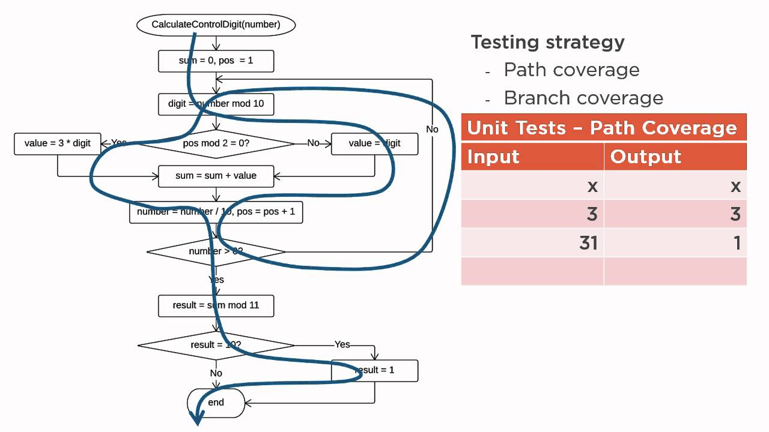

Achieving 100% **decision** coverage guarantees 100% **statement** coverage

## > Experience-Based Test Techniques

### Error Guessing

Error guessing is a technique used to anticipate the occurrence of errors, defects, and failures, based on the tester’s knowledge, including:

* How the application has worked in the past
* What kind of errors tend to be made
* Failures that have occurred in other applications

### Exploratory Testing

Represents informal tests that are performed dynamically during test execution.

**Session-based testing**: testing is conducted within a defined time-box, and the tester uses a **test charter** containing test objectives to guide the testing

Is most useful when there are few or inadequate specifications or significant time pressure on testing

### Checklist-based testing

In checklist-based testing, testers perform tests to cover test conditions found in a checklist.

Such checklists can be built based on experience, knowledge about what is important for the user, or an understanding of why and how software fails.